Name: ________________________________ Mod: ________
Ontario and Quebec
Textbook pages: 290-297

Requirements:
These are done at your desk. You may work with a partner, but each of you is handing in your own work, and your work must not be copied from one another.

___ Read pages 290-297
___ Answer the questions on the back of this sheet
___ Complete the Canadian Government Graphic Organizer (on the back)

Activities:
You must complete three of the following activities.

Station 1: Watch the video on Jacques Cartier. Write a brief summary (3-4 sentences) about the video.

Station 2: Create an acrostic with the words Ontario and Quebec. Use plain white paper provided, and print Ontario on one side. For each of the letters in Ontario, create a word or phrase that demonstrates something you learned from the book about that area. Do the same on the other side with Quebec.

Station 3: Create a mini book with 10 French words and their meanings.

Station 4: Create a words splash using at least 15 words from these pages

Station 5: Create illustrated flashcards for the vocabulary used in this section: federation, Francophone, Quiet Revolution, separatist, Toronto, referendum (p.295), revolution.

Station 6: In the 1960s, the Separatist Movement began to grow, as separatists wanted Quebec to break away from Canada and become a separate union. Pretend you are a Separatist. Design a flag for the “country” of Quebec. The flag must have 3 symbols the French culture you read about. On the back, explain why you chose the symbols.
After reading pages 290-297, answer the following questions:

List 3 important facts about Ontario:

In the 1960s in Quebec, why were the Francophones concerned that their culture might die?

List 5 examples of French culture in Canada.

Complete the words that go with the pictures in the diagram below. Use what you read on pages 291 and the charts and diagrams on page 292.

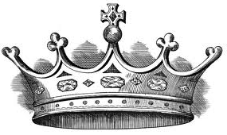 ______________________

_______________________

______________________
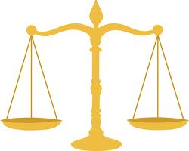
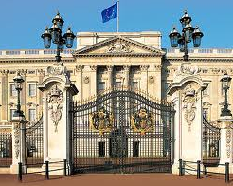

The Parliament has two The judiciary branch has
houses: two levels:
1. 1.

2. 2.

